**CHAPTER ONE**

**INTRODUCTION**

RADAR (Radio detection And Ranging) is a detection system that uses radio waves to determine the distance (ranging), angle, or velocity of objects. It can be used to detect aircraft, ships, spacecraft, guided missiles, motor vehicles, weather formations, and terrain. A radar system consists of a transmitter producing electromagnetic waves in the radio or microwaves domain, a transmitting antenna, a receiving antenna (often the same antenna is used for transmitting and receiving) and a receiver and processor to determine properties of the object(s). Radio waves (pulsed or continuous) from the transmitter reflect off the object and return to the receiver, giving information about the object's location and speed.

* 1. **AIM AND OBJECTIVE OF THE PROJECT**

RADAR system are used specially for object detection and sensing in conditions that are rather difficult to rely on visual effort or instruments, such as long distances and in fogging and unclear whether visibility conditions. The main objective of this project is to outline the process involved in a radar design and successfully design and construct an operational RADAR system to be used in the school for further academic and technological research.

**1.2 SCOPE OF THE PROJECT**

The RADAR is a device produces radio frequency and transmit them into a direction in space where object detection and visualization is intended to be carried out. The RADAR, as the name suggests basically involves sending radio wave at high frequencies for aim of (object) detection and acquiring its range data (ranging) . Traditionally a RADAR is made up of a power supply to power the whole device and oscillator to produce the required radio frequencies to transmitted and a transmitter and a receiver to transmit and receive the reflect radio waves off objects .

**1.3 SIGNIFICANCE OF THE PROJECT**

* The operation of RADAR is essential and importance to many modern infrastructure and technology
* It is relatively cheap compared to other reduced voltage methods.
* Good Torque/Current Performance.
* It draws 2 times starting current of the full load ampere of the motor connected

**1.4 APPLICATION OF STAR-DELTA MOTOR**

The RADAR system is heavily applied to the aviation industry to medium voltage and light starting Torque motors.

The received starting current is about 30 % of the starting current during direct on line start and the starting torque is reduced to about 25 % of the torque. This starting method only works when the application is light loaded during the start.

If the motor is too heavily loaded, there will not be enough torque to accelerate the motor up to speed before switching over to the delta position.

**CHAPTER TWO**

**LITERATURE REVIEW**

**2.1 History of RADAR Technology**

The **history of radar** (where [radar](https://en.wikipedia.org/wiki/Radar) stands for **ra**dio **d**etection **a**nd **r**anging) started with experiments by [Heinrich Hertz](https://en.wikipedia.org/wiki/Heinrich_Hertz) in the late 19th century that showed that radio waves were reflected by metallic objects. This possibility was suggested in [James Clerk Maxwell](https://en.wikipedia.org/wiki/James_Clerk_Maxwell)'s seminal work on [electromagnetism](https://en.wikipedia.org/wiki/Electromagnetism). However, it was not until the early 20th century that systems able to use these principles were becoming widely available, and it was German inventor [Christian Hülsmeyer](https://en.wikipedia.org/wiki/Christian_H%C3%BClsmeyer) who first used them to build a simple ship detection device intended to help avoid collisions in fog (Reichspatent Nr. 165546). True Radars, such as the British [Chain Home](https://en.wikipedia.org/wiki/Chain_Home) early warning system provided directional information to objects over short ranges, were developed over the next two decades.

The development of systems able to produce short pulses of radio energy was the key advance that allowed modern [radar](https://en.wikipedia.org/wiki/Radar) systems to come into existence. By timing the pulses on an [oscilloscope](https://en.wikipedia.org/wiki/Oscilloscope), the range could be determined and the direction of the antenna revealed the angular location of the targets. The two, combined, produced a "fix", locating the target relative to the antenna. In the 1934–1939 period, eight nations developed independently, and in great secrecy, systems of this type: the [United Kingdom](https://en.wikipedia.org/wiki/United_Kingdom), [Germany](https://en.wikipedia.org/wiki/Germany), [the United States](https://en.wikipedia.org/wiki/The_United_States), the [USSR](https://en.wikipedia.org/wiki/USSR), [Japan](https://en.wikipedia.org/wiki/Japan), the [Netherlands](https://en.wikipedia.org/wiki/Netherlands), [France](https://en.wikipedia.org/wiki/France), and [Italy](https://en.wikipedia.org/wiki/Italy). In addition, Britain shared their information with the United States and four Commonwealth countries: [Australia](https://en.wikipedia.org/wiki/Australia), [Canada](https://en.wikipedia.org/wiki/Canada), [New Zealand](https://en.wikipedia.org/wiki/New_Zealand), and [South Africa](https://en.wikipedia.org/wiki/South_Africa), and these countries also developed their own radar systems. During the war, [Hungary](https://en.wikipedia.org/wiki/Hungary) was added to this list.[[1]](https://en.wikipedia.org/wiki/History_of_radar#cite_note-1) The term *RADAR* was coined in 1939 by the United States Signal Corps as it worked on these systems for the Navy.

Progress during the war was rapid and of great importance, probably one of the decisive factors for the victory of the [Allies](https://en.wikipedia.org/wiki/Allies_of_World_War_II). A key development was the [magnetron](https://en.wikipedia.org/wiki/Magnetron) in the UK, which allowed the creation of relatively small systems with sub-meter resolution. By the end of hostilities, Britain, Germany, the United States, the USSR, and Japan had a wide variety of land- and sea-based radars as well as small airborne systems. After the war, radar use was widened to numerous fields including: [civil aviation](https://en.wikipedia.org/wiki/Civil_aviation), marine navigation, [radar guns](https://en.wikipedia.org/wiki/Radar_gun) for police, [meteorology](https://en.wikipedia.org/wiki/Meteorology) and even medicine. Key developments in the post-war period include the [travelling wave tube](https://en.wikipedia.org/wiki/Travelling_wave_tube) as a way to produce large quantities of coherent [microwaves](https://en.wikipedia.org/wiki/Microwave), the development of signal delay systems that led to [phased array radars](https://en.wikipedia.org/wiki/Phased_array_radar), and ever-increasing frequencies that allow higher resolutions. Increases in signal processing capability due to the introduction of solid state computers have also had a large impact on radar use.

**Early contributors**

**Heinrich Hertz**

In 1886–1888 the German [physicist](https://en.wikipedia.org/wiki/Physicist) [Heinrich Hertz](https://en.wikipedia.org/wiki/Heinrich_Hertz) conducted his series of experiments that proved the existence of [electromagnetic waves](https://en.wikipedia.org/wiki/Electromagnetic_waves) (including [radio waves](https://en.wikipedia.org/wiki/Radio_wave)), predicted in equations developed in 1862–4 by the Scottish physicist [James Clerk Maxwell](https://en.wikipedia.org/wiki/James_Clerk_Maxwell). In Hertz's 1887 experiment he found that these waves would transmit through different types of materials and also would reflect off metal surfaces in his lab as well as [conductors](https://en.wikipedia.org/wiki/Electrical_conductor) and [dielectrics](https://en.wikipedia.org/wiki/Dielectric). The nature of these waves being similar to [visible light](https://en.wikipedia.org/wiki/Visible_light) in their ability to be reflected, refracted, and polarized would be shown by Hertz and subsequent experiments by other physicists.

**Guglielmo Marconi**

Radio pioneer [Guglielmo Marconi](https://en.wikipedia.org/wiki/Guglielmo_Marconi) noticed radio waves were being reflected back to the transmitter by objects in radio beacon experiments he conducted on March 3, 1899 on Salisbury Plain. In 1916 he and British engineer [Charles Samuel Franklin](https://en.wikipedia.org/wiki/Charles_Samuel_Franklin) used short-waves in their experiments, critical to the practical development of radar. He would relate his findings 6 years later in a 1922 paper delivered before the Institution of Electrical Engineers in London:

I also described tests carried out in transmitting a beam of reflected waves across country ... and pointed out the possibility of the utility of such a system if applied to lighthouses and lightships, so as to enable vessels in foggy weather to locate dangerous points around the coasts ... It [now] seems to me that it should be possible to design [an] apparatus by means of which a ship could radiate or project a divergent beam of these rays in any desired direction, which rays, if coming across a metallic object, such as another steamer or ship, would be reflected back to a receiver screened from the local transmitter on the sending ship, and thereby immediately reveal the presence and bearing of the other ship in fog or thick weather.

**Christian Hülsmeyer**

In 1904, [Christian Hülsmeyer](https://en.wikipedia.org/wiki/Christian_H%C3%BClsmeyer) gave public demonstrations in [Germany](https://en.wikipedia.org/wiki/Germany) and the [Netherlands](https://en.wikipedia.org/wiki/Netherlands) of the use of radio [echoes](https://en.wikipedia.org/wiki/Echo_(phenomenon)) to detect [ships](https://en.wikipedia.org/wiki/Ship) so that collisions could be avoided. His device consisted of a simple [spark gap](https://en.wikipedia.org/wiki/Spark_gap) used to generate a signal that was aimed using a [dipole antenna](https://en.wikipedia.org/wiki/Dipole_antenna) with a [cylindrical](https://en.wikipedia.org/wiki/Cylindrical) [parabolic reflector](https://en.wikipedia.org/wiki/Parabolic_reflector). When a signal reflected from a ship was picked up by a similar antenna attached to the separate [coherer](https://en.wikipedia.org/wiki/Coherer) [receiver](https://en.wikipedia.org/wiki/Receiver_(radio)), a bell sounded. During bad weather or fog, the device would be periodically spun to check for nearby ships. The apparatus detected the presence of ships up to 3 kilometers (1.6 nmi), and Hülsmeyer planned to extend its capability to 10 kilometers (5.4 nmi). It did not provide range (distance) information, only warning of a nearby object. He patented the device, called the *telemobiloscope*, but due to lack of interest by the [naval](https://en.wikipedia.org/wiki/Naval) authorities the invention was not put into production.

Hülsmeyer also received a patent amendment for estimating the range to the ship. Using a vertical scan of the horizon with the *telemobiloscope* mounted on a tower, the operator would find the angle at which the return was the most intense and deduce, by simple triangulation, the approximate distance. This is in contrast to the later development of pulsed radar, which determines distance via two-way transit time of the pulse.

**Working Principle of a RADAR**

RADAR typically works on the principle of tracing back a portion of the transmitted radio wave that gets reflected upon striking the surface of a rigid object. A radio wave is a form of electromagnetic wave that has a wavelength ranging from 30 cm to thousands of meters. The frequency level of radio waves lies between 3 hertz to 1 gigahertz. The radio bursts transmitted by the transmitter of RADAR tend to travel towards and away from the target object at the speed of light; therefore, appear to exist for an extremely short duration of time. The portion of the radio wave that gets reflected back after hitting the target is known as echo. This echo signal contains the information required to determine the shape, size, location, angle, range, velocity, and various other characteristics of the target object. In simple words, the entire operation of a RADAR depends on the analysis of the reflected wave. RADAR has the ability to detect the position and characteristics of static as well as moving objects. It can also tell whether the target object is moving away from or towards the RADAR. Usually, in a RADAR set, the transmitter antenna itself acts as the receiver antenna. The transmitted signal tends to lose a significant amount of energy after striking the target object; hence the reflected signal gets attenuated in the process and is required to be amplified after the reception. The amplification of the reflected signal is done up to several million times. The retraced signal after processing is further used to deflect the electron beam in the cathode ray tube. This causes a light indicator to appear on the display unit that points towards the direction of the target object. The display of RADAR consists of a fluorescence layer that enables the glow of light to stay for a longer duration and change only after the next echo signal is received. The coordinates and the distance of the target get displayed directly with the help of the indicator tube. The angle at which the target moves towards or away from an object is determined by estimating the direction from which the reflected signal is obtained. The angular value of the target can be expressed by two components, namely azimuth angle and elevation angle. The azimuth angle is measured along the horizontal plane, while the elevation angle is measured along the vertical axis or the vertical plane.



**CHAPTER THREE**

**METHODOLOGY**

The approach to this design is realized through the design and construction (mostly assembly) of its components which as stated earlier are it Transmitter, Antenna, Receiver and some form of display unit. But the icing to the cake would be the software implementation that allows the analog signal/data captured by the RADAR system setup to be digitalize for accessibility and further research. In order to achieve these, programs are going to be written by the design team to aid in manipulating the voltage input (radio echo signal) gotten from the receiver into meaning digital/visual formats which would be used to obtain and extract information about the detected object.

**3.1 Principles Applied in the design**

The principles applied in this paper are based on engineering concept.

These principles are listed below:

* Modulation of Radio wave to enable transmission with relatively small antenna sizes
* Reflection of Electromagnetic waves from an object
* Doppler Effect on Waves when observed from a reference point with relative motion to the wave producer (source)

**3.2 Components and materials**

The components/materials used for the construction of the Radar system are explained below with their uses in the project

**3.2.1 Antenna (Parabolic Antenna)**

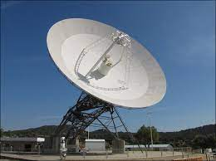

**Fig 3.x: Typical Parabolic Antenna (Dish)**

An Antenna or an Arial is the interface between radio waves propagation through space and electric currents moving in the metals conductors, used with a transmitter or receiver.

A parabolic antenna is an antenna that used a parabolic reflector, a curved surface with cross-sectional shape or a parabola, to direct the radio waves to the receiver in its focal point. The most common form is shaped like a dish and popularly called a dish antenna or parabolic dish

**3.2.2 Transceiver Unit**

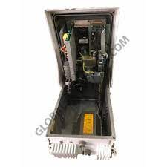

**Fig 3.x: Typical Transceiver**

A Transceiver is a combination of transmitter and receiver in a single package used to convert electronic signals into EM signals and vice versa

1. **Transmitter**

A Transmitter is en electronic device that produces radio wave with an antenna. The Transmitter itself generates a radio frequency alternating current, which is applied to the antenna. When excited by the alternating current, the antenna radiates radio waves.

1. **Receiver**

A receiver is a device that accepts signals, such as radio waves, converts and amplifies it into a useful form. it is used with antenna. The antenna intercepts radio waves (electromagnetic waves of radio frequency) and converts them to tiny alternating currents which are applied to the receiver, and the receiver extracts the desired information. The receiver uses electronic filters to separate the desired radio frequency signal from all the other signals picked up by the antenna electronic amplifier to increase the power of the signal for further processing and finally recovers the desired information through demodulation

**3.2.3 Duplexer**

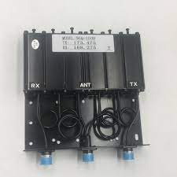

**Fig 3.x: Radar Duplexer**

A Duplexer is an electronic device that allows bi-directional communication over a single path. In Radar and Radio Communication systems it isolates the receiver from the transmitter while permitting them to share a common antenna. Most radio repeater systems include a duplexer. Duplexer can be based on frequency (often a waveguide filter), polarization (such as an orthomode transducer), or timing (as is typical in radar).

**3.2.4 Processing Unit**

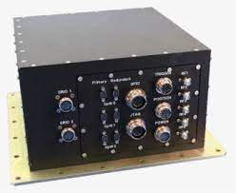

**Fig 3.x: Radar processing unit**

The Radar controller and processing unit (RCPU) is a radar sub-system providing resources for Radar Signal Processing, Radar Data Processing and Radar Data Recording. The RCPU consists of the following lines-replaceable units (LRUs)

* Signal Processor
* Data Processor and Controller Unit (DPCU)
* Radar Data Recorder Unit (RDRU)
* Power Distribution and Control Unit (PDCU)

**3.2.5 Radar Display Unit/System**

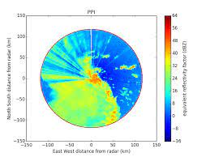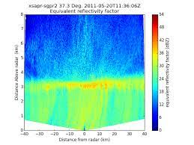

**Fig 3.x: Example of Radar Display (visual output)**

A Radar display is usually an electronic device to present radar data to the operator. The radar system transmits pulses of continuous waves of electromagnetic radiation, a small portion of which backscatter off targets (intended or otherwise) and return to the radar system. After the receiver converts all received all received electromagnetic radiation into a continuous electronic analog signal of varying (or oscillating) voltage that can be converted then to a screen display. In our case we intend the achieve this conversion by a using a computer program that intercepts the analog electronic signal and produces a data structure which can be manipulated to produce meaningful and accurate radar readings digitally.

**3.3 Material Selection**

The selection of materials for the fabrication seems like a very complicated process for engineers. In making good selection of material there are some factor to be consider which are:

* Material properties: The expected level of performance form the material
* Material cost and availability: material must be priced appropriately and the material must be readily available or abundant in nature to use.
* Processing: must consider how to make the part either casting, machining , welding or assembly
* Environmental reaction: Reaction between material and its environment must be favourable and the material must be able to withstand the environment conditions without much deformation.

**3.4 Principle of Operation**

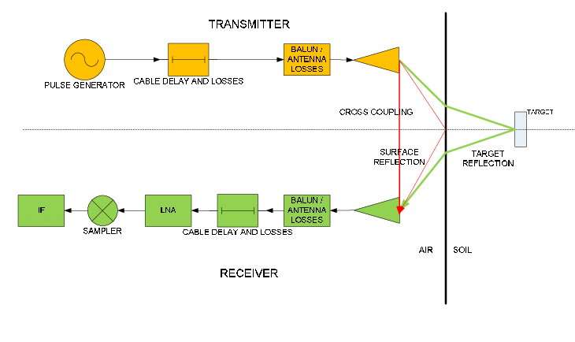

**Fig. 3.x: Schematic Diagram of a Radar System**

The designed system consist primary of a Transmitter and a Receiver Subsystem, the transmitter subsystem is responsible for generating and then transmitting the specified radio signal into the direction that is be observed. When the radio waves comes in contact with a object, some part of it is absorbed by the object and some other portion of it is reflected (scattered), therefore some move back to the antenna and Duplexer system is used to isolate the path of the incoming signal to move to the receiver subsystem, upon reception by the receiver subsystem the echo radio signal is processed and finally passed on to some storage system or display unit for further analysis or to obtain the necessary information about the object it was reflected from , those information include, Range (distance of the object from the Radar’s Antenna) and its relative velocity with the radar system. Other information like size, conductivity and density can also be obtained from the reflected radio waves.

**3.5 Design Specification**

|  |  |
| --- | --- |
| Operating Frequency | **5.3GHz** |
| Waveform Bandwidth | **200MHz** |
| Base-bandwidth | **1MHz** |
| Transmit Power | **15W** |
| Maximum Chip Length | **5ms** |
| Maximum Range | **3750 m** |
| Array Beamwidth | **0.6o** |

**3.6 Design Analysis**

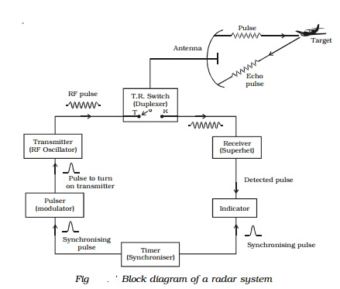

**Fig 3.x: Block Diagram of a Radar System**

**3.7 Design Procedure**

According to the block diagram above the radar system was primary composed of 2 subsystems for transmission and reception of radio signals and the other components that aided that interfacing to work properly.

Transmitter Subsystem: In the transmitter subsystem the RF oscillator is used along side the Pulse Modulator which modulates the generated RF signal to desired form and then forwards the modulated RF alternating current to the Duplexer which manages the communication of signal to and fro the Antenna

Receiver Subsystem: in the receiver subsystem the receiver get the echo signal from the target object and processes it and the output of the processed signal is passed on to some other interface either for visual presentation or for storage or further processing etc

Antenna: the antenna is the central component to the functioning of the whole systems as it is responsible for directing signals generated by the transmitter subsystem and receiving echo signals from the target intened for the receiver subsystem.

**3.8 Precautions**

* Ensure that the proper power levels is included in the design of the system
* Check that the condition of the antenna is good and radio waves are directed and reflected properly.
* Check that the cables connecting the different components are electrically continuous and connected properly.
* Using the proper glass recommended for welding machine

**CHAPTER FOUR**

**5.1 Conclusion**

The design and construction of a radar system has been successfully presented in this research.

In this project, much research has been made into radio technology and its requirement in order to be able to determine the required electrical and physical characteristics for designing and building a radar system.

The successful completion of this research has broken the mystery behind Radar systems. The study will be of great importance to Engineers, Technologies, Technicians, Artisans and those involved in Radar developments, research and maintenance.

**REFERENCE**

https://studiousguy.com/working-principle-radar/

https://en.wikipedia.org/wiki/History_of_radar

<https://link.springer.com/content/pdf/bfm%3A978-1-4613-1971-9%2F3%2F1.pdf>

https://www.researchgate.net

https://www.tutorialspoint.com/radar_systems/radar_systems_pulse_radar.htm

https://www.radartutorial.eu/01.basics/rb67.en.html

https://www.toppr.com/ask/question/explain-the-principle-and-working-of-radar-with-neat-block-diagram/

https://nanopdf.com/download/23-radar-block-diagram-and-operation_pdf

Radar System Design (final version) project by

Lamis Islam Ahmed-zaki

Marwa Mostafa Hedayah

Mostafa Mohsen Mostafa Kamal

Shady Mohamed Mahmoud

https://electronicsdesk.com/radar-system.html

https://www.davuniversity.org/images/files/studymaterial/Radar%20System%20_notes.pdf